+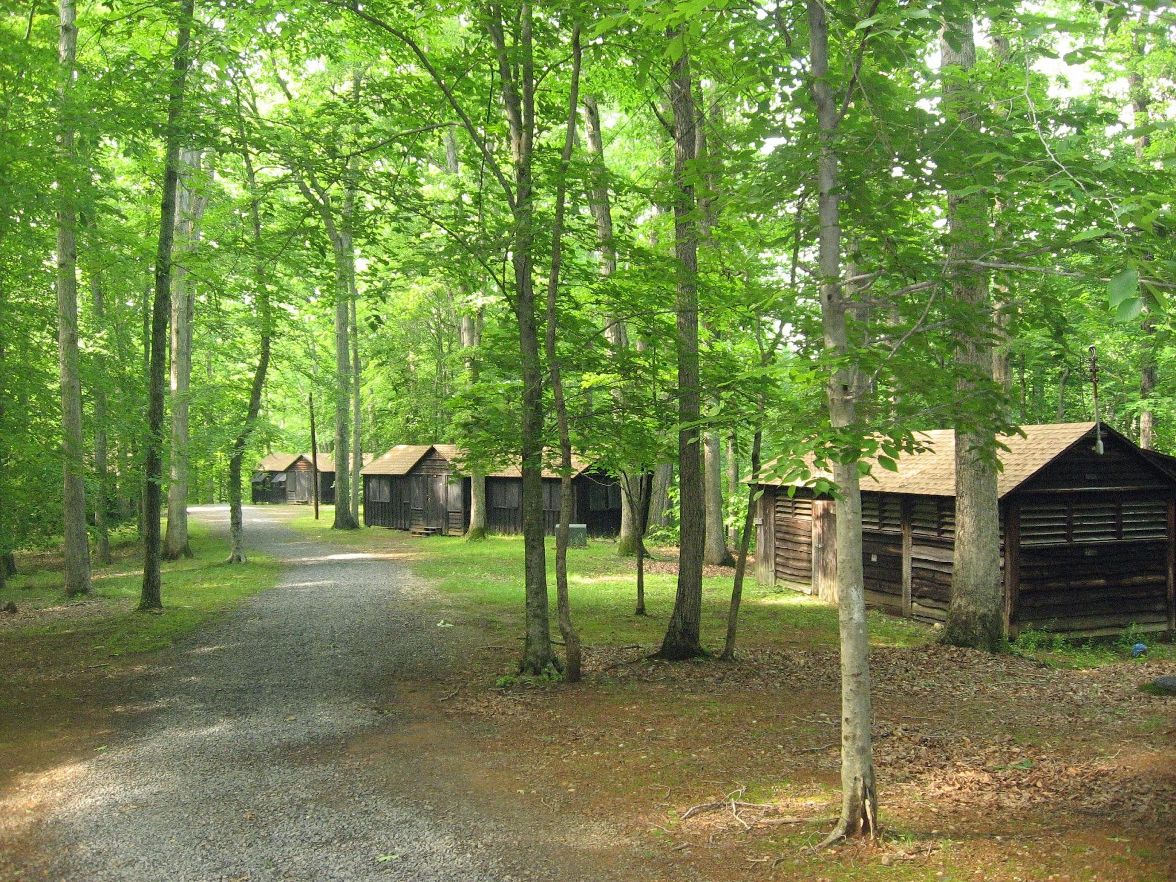

Cornerstone Family Worship

Invite you!

CKC Camp 2025@ Camp Mt. Hermon

23801 Parallel Rd.

Tonganoxie, Ks 66086

It’s that time of year again. We are excited to announce that Cornerstone family worship Leaders will be hosting our 3 day camp @ camp Mt. Herman. June 5,6,7th, check in is at 8am the 5th, pick up @ 4pm the 7th. Ages Kindergarten to 6th graders, $50 per child.

All in the great outdoors, you can choose to send kids for the night or pick them up each day. We know some kiddos don’t like to spend the night away from home so day campers will come 8AM-8PM daily . We have limited cabins for boys/girls so sign up soon and Invite your friends.

What to expect: learning about what God has for us, games, waterslide, (wet)giant slide,camp fires, worship, good food, great outdoors, bugs, dirt, hiking and a lot more.

Register online or pick up your packet at Cornerstone Family Church. As said we have limited space so sign up quickly and reserve your spot. If you have any questions please feel free to call/email Kelli Morris-913-620-9916/ Kelli@cfwchurch.com.

Cut off date is May 26th,no exceptions.

**Camper/s Information**

Camper/s Name:___________________________________________________________

Date of Birth: _______________________________Current Grade in school:___________

Address, City,State___________________________________________________________

Phone:_________________________________ T-shirt size:___________

**Parent/Guardian Information**

Mom name:_________________________________________

Address(if different from above)______________________________________

Phone:_____________________________________________

Email:________________________________________________

Dad name:____________________________________________

Address(if different from above)______________________________________

Phone:__________________________________

Email:______________________________________

**Emergency contact**

Name:___________________________________________

Relationship to camper:____________________________________

Phone:__________________________________

Email:______________________________________

**Reservation**

Day camper ______

Cabin:_________

**Transportation**

Parent/Guardian authorized to pick up camper: _______________________________________________________

If needed whom is **NOT** authorized to pick up camper: _______________________________________________________

**Social media/Pictures**

Yes or No (circle one)

**Health Information**

Doctor’s Name:___________________________________________

Phone:__________________________________________________

Preferred Hospital:_________________________________________

Past history of serious injuries or illnesses we should know:___________________________________________________________________________________________________________________________________________________

Taking any prescription:_________________________________________________________

**Allergies/Reaction**

To Drugs:____________________________________________________________________

To food:______________________________________________________________________

Special dietary requirements_____________________________________________________

____________________________________________________________________________

Other:_______________________________________________________________________

Over the counter medications **NOT** permitted:________________________________________

**Authorization For Emergency Medical Care**

By signing below, I hereby give my permission to Cornerstone Family Worship officials to call a doctor or emergency medical service, and for the doctor or medical service to provide emergency medical or surgical care for my child(ren) should an emergency arise. It is understood that Cornerstone Family officials will make a conscientious effort to locate the emergency contact, Parents/Guardian listed on camp registration form, before any action is taken. If it is not possible to locate emergency contact, Parents/Guardian listed, I/we Cornerstone officials accept responsibility to seek emergency medical or surgical treatment per doctor's order until emergency contact, Parent/guardian are contacted or arrive.

Sign________________________________________ Date_________________________

**Release, Waiver and Indemnity Agreement**

It is the intention of ______________________________________(parent or guardian)

by this agreement to Exempt and relieve Cornerstone Family Worship and Camp Mt.

Hermon and it’s officer, agents, servants or employees from liability for personal injury,

property damage, or wrongful death of _____________________________________

(name of minor) caused by any act of negligence of Cornerstone Family Worship and

Camp Mt. Hermon and its officers, agents, servants or employees.

For in and in consideration of permitting _______________________ (name of minor)

to observe, or use any facility or equipment of Cornerstone Family Worship and/or

Camp Mt. Herman, or engage in and/or receive instruction in any activity or activity

incidental thereto some of which may involve dangers and risk of bodily injury at Camp

Mt Hermon facilities and/or Cornerstone Family Worship in the city of Tonganoxie,

County of Leavenworth, and State of Kansas, beginning on the date of June 5, 2025

through June 7,2025, the undersigned parent and or guardian of

_________________________ (name of minor): Hereby voluntarily and absolutely

releases, discharges, waives, and relinquishes any and all loss or damages or actions

or causes of action for personal injury, property damage, or wrongful death occurring to

_________________________ (name of minor) as a result of

________________________’s (name of minor) observing or using facilities or

equipment of Camp Mt. Hermon and/or Cornerstone Family Worship, or engaging in or

receiving instructions in any activities some of which may involve dangers and risk of

bodily injury or in activities incidental thereto wherever or instructions may continue.

The undersigned parent or guardian of ___________________________ (name of

minor) for him/herself, his/her heirs, executors, administrators, or assigns agrees that in

the event any claim for personal injury, property, damage or wrongful death shall be

prosecuted against Cornerstone Family Worship and/or Camp Mt. Hermon or its

officers, agents, servants or employees, the undersigned parent or guardian will

indemnify and hold harmless Cornerstone Family Worship and /or Camp Mt. hermon

and it’s officers, agents, servants or employees from any and all claims or causes of

action by _________________________ (name of minor) or by any other person or

entity, by whomever or wherever made or presented, and under no circumstances will

the undersigned parent or guardian of _________________________ (name of minor)

present any claim against Cornerstone Family Worship and/or Camp Mt Hermon and

said persons for personal injuries, property damage, wrongful, or otherwise, caused by

any act of negligence by Cornerstone Family Worship and/or Camp Mt. Hermon and

said persons.

Parent or Guardian Initials_________

The undersigned parent or guardian represent that he/she has read this release, has

requested and has been provided with, or has requested and decided advisement on

the potential dangers/risks associated of engaging in the observation, activities, or

instruction offered, assumes all risks associated with such dangers and risks, and is

fully aware of and understand the terms and legal consequences of the signed of this

release. The undersigned parent or legal guardian intends his or her signature to be a

complete and unconditional release of all liability to the greatest extent allowed by law

and if any portion of the release is held invalid, it is agreed that the balance shall,

notwithstanding, continue in full legal force and effect.

Dated: ______________________

Name of Minor ___________________________________

Signature of Parent or Guardian: __________________________________________

Printed name of parent or guardian: _______________________________________

**WHAT TO BRING:** **WHAT NOT TO BRING:**

Bible/journal or small notebook Cell phones(for any reason)

Pen/pencil Candy/food

Sleeping bag/bedding for twin & pillow Knives

2 towels (1 for water activities) Any kind of electronic (ipad,radio

Soap/shampoo/hygiene products stereo,games, cd/cd player

Toothbrush/toothpaste

Casual/recreational clothing/socks Attitudes 🙂

Jacket/sweatshirt No flip flop

Raincoat/poncho

Modest swimsuit/cover up/water shoes

Tennis/athletic shoes only/shoes have to cover entire foot

Sunscreen & insect repellent

Flashlight/ lawn chair

Medications in original containers with direction

Forms: registration/copy of insurance card(if registered online we will make a copy of the signed form) we will need a copy of insurance card.

If you are unsure about whether to bring an item, Please feel free to contact Kelli Morris, 913-620-9916. All of our adult leaders will have phones, if your child needs to contact you. If you need to contact us, here is a list of numbers and email.

Kelli Morris- CFW Leader[-913-620-9916-Kelli@cfwchurch.com](mailto:leader-913-620-9916-Kelli@cfwchurch.com)

Lynnette Abbott-Camp Mt. Hermon Leader- 913-845-2586, Labbottcampmounthermon@gmail.com